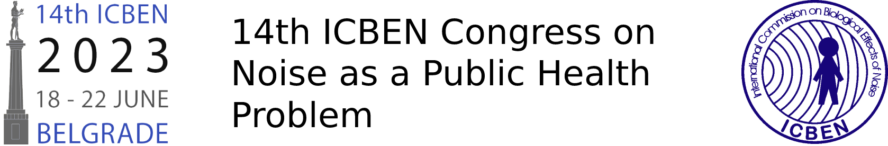

This is the title which should be without abbreviations and no longer than two lines

**1Toto Amante1, Fritz Unmöglich2, Piggy Sue3**

1 University of Love, Institute of Making Noise, Python City, Republic of Nowhere

2University of Gili Gili, Institute for Impossible Research, Gili Gili, Neverland

3Hardrock College, Center of Funny Acoustics, Hardrock, People's Republic of Jingle Jangle

Corresponding author's e-mail address: [funmoglich@giligili.edu.nd](mailto:funmoglich@giligili.edu.nd)

**ABSTRACT**

Please use this template when submitting your abstract. The abstract should be written in one paragraph. Please use American or British English, but not a mixture of both. The abstract size is up to 250 words. The abstract should be language and spell-checked and properly formatted based on this template before being uploaded. There should be no abbreviations and citations in the abstract. We highly appreciate your contribution.

Keywords (3-6): Noise, Silence, Screaming, Singing, Laughing, Crying